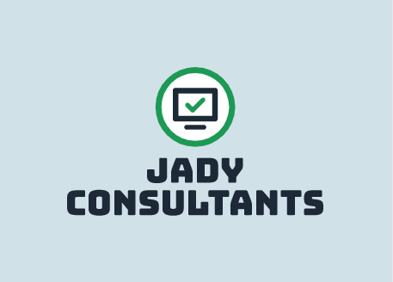

JADY Consultants

1 College Way

Pembroke, ON, K8A 0C8 Great logo!

Friday, February 18, 2022

Mr. Joe Veryard Algonquin College Place “Algonquin College” on the next line.

1234 Woodroffe Ave.

Ottawa, ON K8H 7J6

Subject: Website Development

Dear Mr. Veryard,

Thank you for reaching out to us! We are very happy to work with you in creating your website. We are JADY Consultants, a full stack web solutions company. Our team has four highly experienced full stack developers with experience using the latest web technologies. JADY provides some of the fastest lead times from design to deployment and we collaborate with you every step of the way. We would like to get a better picture of how you want your website to look and feel like, so we have prepared a few questions below: You have provided an excellent introduction to your company and your persuasive tone should help to convince me to go with your company. Don’t forget to provide a brief summary of what you already know about my needs to ensure that your information to this point is correct.

1. What do you want your visitors to do on the website? I would like visitors to the site to be able to gather and exchange information on policies, issues and promising practices related to safe schools.
2. What is your budget for this project? I have permission to spend up to $30,000 but this includes ongoing maintenance of the site for the duration of the contract.
3. Do you have any specific colour palette in mind? I have not really considered colour palettes but would be interested in your recommendations. The key concern in this area would be having good contrasts between background and information shared.
4. What does your timeline look like (estimated completion date)? I would like to have the site ready for a soft launch in September 2022.
5. How many pages would you like on the site?
   * What would they be? (Home/Blog/Information/Contact…) My main wish is for fewest clicks for easy access to all aspects of the site, so I will leave the number of pages to your professional judgement.
6. Would you like the website to include cookies that would customize the visitors’ experience (Dark mode/light mode, saving usernames, saving password, etc.)? I feel that this would be valuable.
7. Would you like the website to have a mobile version? If this could be done within budget, that would be ideal.
8. Would you like users to be able to create accounts and passwords for themselves? For principals, yes. If we are including a section for the public this would not be necessary, though. If possible, I would like to be able to track use of the different aspects of the site to see what aspect appears to be of greatest value to specific users.
   * If so, during the account creation process what identifier would be used to ensure that the person creating the account is a member of the principal counsel? I will have access to names and contact information for the people who should have access. This could be shared with you.
9. What is the website supposed to be (Blog, social networking, portal, etc.)? Since the main purpose is sharing of safe schools’ information as indicated above, it would be important for it to include a repository for print and video resources that people could access and add to, if desired. There should be a discussion feature as well as a newsfeed with up-to-date information on safe schools’ issues. Ideally, a calendar of events and an option to purchase resources or sign up for conferences would be included. If possible, there should be an aspect of the site exclusive to the principals with other areas that could be available to other stakeholder groups.
10. Would you like to add a discussion forum to give your stakeholders a platform to interact with each other? Yes.

If you have any specific requirements for your website, please let us know. We are very pleased to be working with you and we look forward to hearing back from you soon! Your concluding paragraph is somewhat brief. What is the preferred method for the client to get back in touch? Is there a plan for further exchange of information? Beyond the sharing of answers, what are the next steps. Any or all of these areas would be good focal points for this final paragraph.

Sincerely,

Jordan, Angela, Diana, & Yohanes